[INSERT NAME OF SCHOOL] School WASH Bottleneck Analysis report

[INSERT DATE BNA Report completed]
PLACE PHOTOGRAPH OF SCHOOL BUILDINGS

This report is to provide summary of WASH Bottleneck Analysis baseline findings for [INSERT NAME OF SCHOOL] Primary School
Data and information summarised in this report was collected on [INSERT DATE OF BNA DATA COLLECTION] by:
(INSERT NAME/S OF PROJECT STAFF WHO DID THE BNA
The key target audience for this report is the leadership of [INSERT NAME OF SCHOOL] Primary School, [INSERT NAME OF PROVINCE] Provincial Education Authority, and for Live & Learn reporting purposes. A copy of the report is to be shared with the leadership of [INSERT NAME OF SCHOOL] Primary School.
This report was produced through the Resilient WASH in the Islands Region and ARoB project - supported by the Australian Government and implemented by Plan International Australia and Live & Learn Environmental Education

School profile
PLACE MAP OF SCHOOL LOCATION FROM M-WATER

Name: [INSERT SCHOOL NAME] Primary School
Type: Primary School
Location (take from M-Water)
Example Only
- GPS Coordinates: -9.348950, 159.822999 Location Altitude: 115.838
- mWater ID: 27037456
Enrolment as at [INSERT DATE OF BNA SURVEY DATA COLLECTION]
- Female Students: ??
- Male Students: ??
Teaching Staff as at [INSERT DATE OF BNA SURVEY DATA COLLECTION]
- Head Teacher: [INSERT FULL NAME OF HEAD TEACHER]
- Female Teachers: ??
- Male Teachers: ??
Briefly describe any key factors for the school – location, surrounding community, etc (anything important not covered in the BNA survey questions). Suggestions – presence of logging camp, new leadership at the school, etc

Bottleneck Analysis
 | Indicators |  | Colour Rating & Analysis from Survey Data
WATER | No Star - Red  - No drinking water for children |  | Note – only write notes for the school’s current level. Leave other sections empty
WATER | 1 STAR - Orange  - Children bring water bottle from home
WATER | 2 STARS - Green  - School promotes low cost point of use water treatment options, such as boiling, filtration, solar disinfection
WATER | 3 STARS - Blue  - School has an improved water source (piped, gravity-fed, protected spring or well or borehole, rainwater).  - School meets national standards:  - Minimum 5 litres per day per student  - Drinking water 100% e-coli free  - Meet tap ratio of 1:100 urban schools and 1:50 rural schools  - Waste water safely drained away

 | Indicators |  | Colour Rating & Analysis from Survey Data
SANITATION | No Star - Red  - School has no toilets |  | Note – only write notes for the school’s current level. Leave other sections empty
SANITATION | 1 STAR - Orange  - Minimum of 2 VIP toilets each, separate for boys and girls, and 1 VIP toilet for teachers
SANITATION | 2 STARS - Green  - Improved toilet (VIP/Pour Flush/Septic) functioning and available.  - Toilet:Student Ratio for girls – 1:40  - Toilet:Student Ratio for boys – 1:50, with urinals  - Changing room for girls provisioned with sanitary napkins, re-usable cloth pads, soap/ash and water
SANITATION | 3 STARS - Blue  - Toilet:Student Ratio for girls – 1:25  - Toilet:Student Ratio for boys – 1:40, with urinals  - School meets national standards:  - Toilets are light, bright, ventilated and in appropriate location, with enough toilets and suitable design to prevent long waiting times  - Toilet accessible to children with disabilities

 | Indicators |  | Colour Rating & Analysis from Survey Data
HYGIENE | No Star - Red  - No hygiene promotion  - No student WASH Club |  | Note – only write notes for the school’s current level. Leave other sections empty
HYGIENE | 1 STAR - Orange  - No open defecation  - Presence of a hand-washing facility with water and soap/ash outside toilet  - Student WASH Club in place but inactive
HYGIENE | 2 STARS - Green  - Daily supervised cleaning of toilets  - Daily supervised group hand washing with soap  - The school has and supports one or more active student WASH Clubs, with Terms of Reference (report on female and male membership of WASH Clubs and activities)  - Boys and girls receive discreet menstrual hygiene management education  - Regular WASH hygiene promotion activities are conducted  - Evidence of IEC materials at strategic location  - Deworming and iron folic acid supplementation provided by health official
HYGIENE | 3 STARS - Blue  - Institutionalised hygiene education in schools  - WASH hygiene promotion is integral part of school curriculum and teaching education  - School meets national standards:  - Hand washing facility ratio of 1:50, separated by gender and special needs.  - Minimum of 1 hand washing facility inside/outside toilet and near school dining area or market place

 | Indicators |  | Colour Rating & Analysis from Survey Data
School WASH Management | No Star - Red  - No WASH Committee / School Water Management Group  - No WASH Improvement Plan or budget allocation  - No cleaning rosters for school WASH facilities, and no involvement of staff and students |  | Note – only write notes for the school’s current level. Leave other sections empty
School WASH Management | 1 STAR - Orange  - WASH Committee appointed but inactive, WASH Improvement Plan in place, but not integrated into SLIP  - School WASH Plan budget is drafted but no funds allocated in SLIP  - Cleaning roster in place, but not implemented consistently
School WASH Management | 2 STARS - Green  - Active WASH Committee has a budgeted School WASH Improvement Plan (inclusive of a routine operation and maintenance plan and an improvement plan), integrated into the SLIP  - Maintenance management role is defined for WASH activities. School keeps records to demonstrate that the WASH plan is being implemented.  - School has daily cleaning rosters for school WASH facilities documented and followed

Source: Independent State of PNG Department of Education, Policy and Standards for Water, Sanitation & Hygiene (WaSH) in Schools 2018-2023

Additional Information

ENABLING ENVIRONMENT

School governance
Brief comments on school board structure and school management (cohesive? Supportive? Active?)

Enabling WASH actors
If there is no WASH Committee established state this fact and proceed to describe key local stakeholders and related roles and responsibilities that could be useful for improved WASH. Consider the role of the following stakeholders
School management, Teachers, PTA, local government, local church, students, other…

Current prioritised Challenges for WinS
Challenges and priorities as described in Principal/Head Teacher Survey and Teacher/Parent Survey

Budget available for WASH in Schools
Any relevant comments on the school financial situation (debts, acquittals for government grants, etc)

Access to water
Insert data from mWater Infrastructure Spot Check survey (export data from M-Water into Excel)
 | Type of water source available | Number of this source available at school | Number of outlets/taps | Availability of source
1 | Piped Water (school supply only) | 1 | 1 | Always available
2
EXAMPLE ONLY

Summary of School Toilets
Insert data from mWater Infrastructure Spot Check survey (export data from M-Water into Excel). Include ALL toilets in the school that were surveyed
EXAMPLE ONLY
 | Type of toilet | Designated user | Toilet paper? | Water for flushing (if water based toilet) | Is it private? | Can the door be locked from inside? | Is there a bin for waste? | Cleanliness of toilet bowl | Location of nearest handwashing facility | Condition of structure
1 | Pour flush | anyone / not specified | No | No | No | No | No | Visible faeces | outside toilet block (within 10m) | Good
2 | Button flush | female student | No | No | Yes | No | No | Clean | Inside cubicle | Good

Summary of Hand Washing Faciliites
Insert data from mWater Infrastructure Spot Check survey (export data from M-Water into Excel). Include ALL Hand Washing Facilities in the school that were surveyed
EXAMPLE ONLY
 | Type of handwashing point | Number of taps/outlets | Location of handwashing facility | Is water currently available at handwashing facility? | Is soap available? | Is handwashing facility clean? | Is water drained away safely?
1 | Tapstand | 1 | Outside toilet block (less than 10m) | Yes | No | No | No
2 | Tapstand | 1 | Outside toilet block (less than 10m) | No | No | Yes | Yes

Environmental Sanitation
Provide short comments on: School drainage systems and waste management from Infrastructure Spot Check

ON THIS PAGE PLACE PHOTOS OF WATER SUPPLY, TOILETS AND HAND WASHING FACILIITES FROM mWATER SPOT CHECK SURVEY

STUDENT Knowledge, Attitude & Practice Survey Responses

Total Students Interviewed: XX Girls: XX (%) Boys: XX (%)

Student demand for Access to WASH Facilities
Insert graphs from mWater Student KAP Survey Report/Dashboard into each table cell – below are examples to show which graphics to place in each cell. Leave the headings, just insert the graphics

Independent Handwashing With Soap – Reported
Before the last meal you ate, did you?  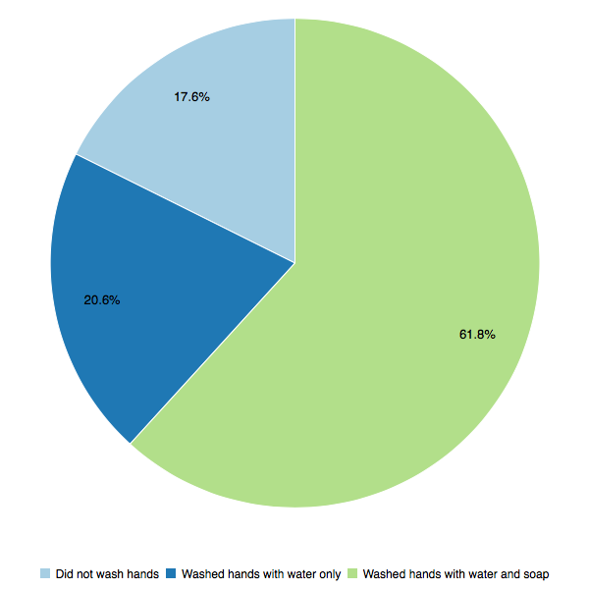 | The last time you did a poo at school, did you?  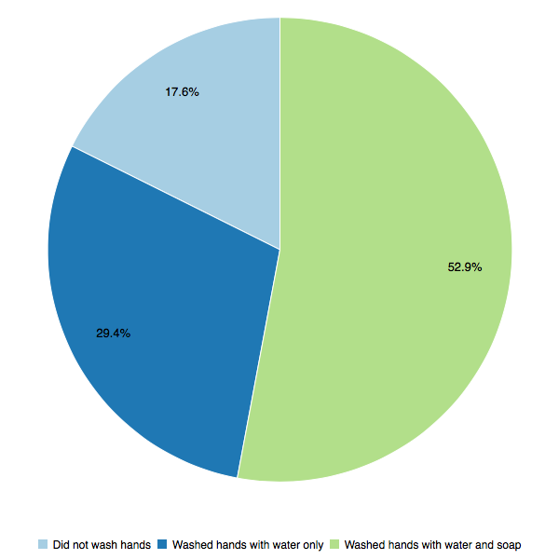

Structured Observation Results
EXAMPLE ONLY
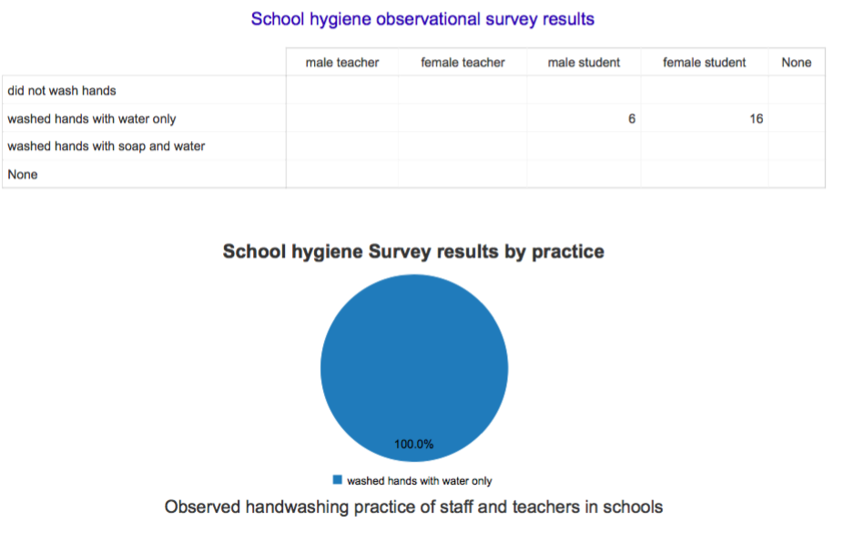

Toilet use
EXAMPLE ONLY
How do you feel about the school toilets?  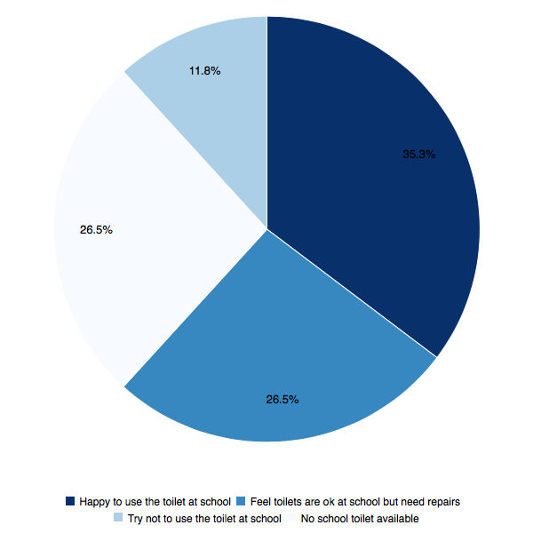 | During menstruation, do you….  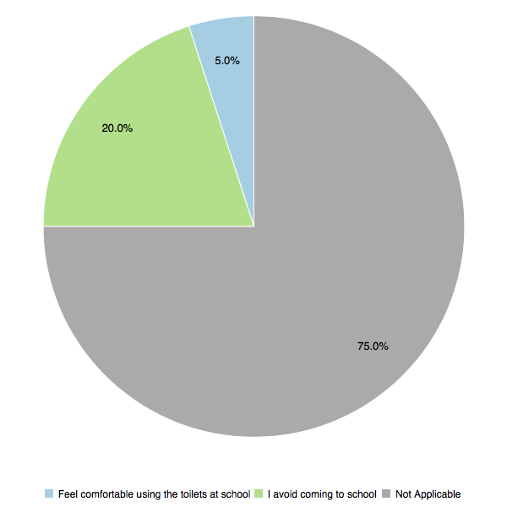

Class Education At School – WASH & Inclusion
EXAMPLE ONLY
Do you remember any school lesson that talked about hygiene or cleanliness?  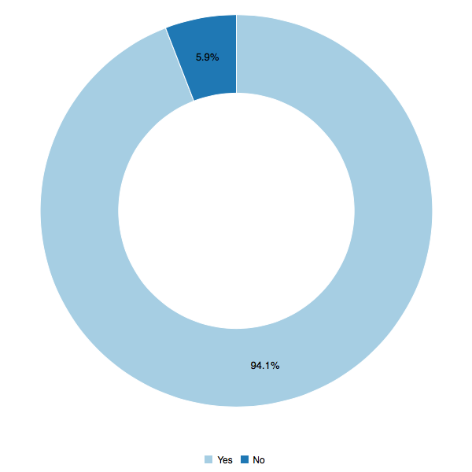 | Do you remember any school lesson about safe drinking water at school?  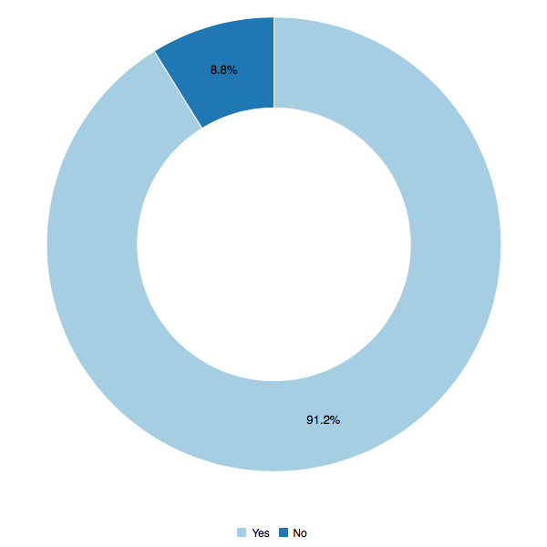
Do you remember any school lesson that talked about menstruation or girl’s periods?  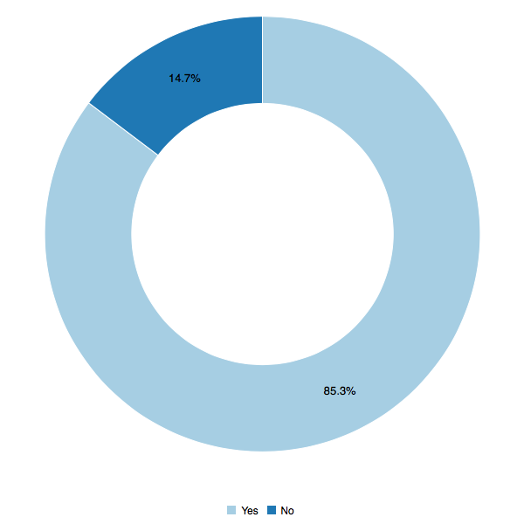 | Do you remember any school lesson that talked about child rights or human rights?  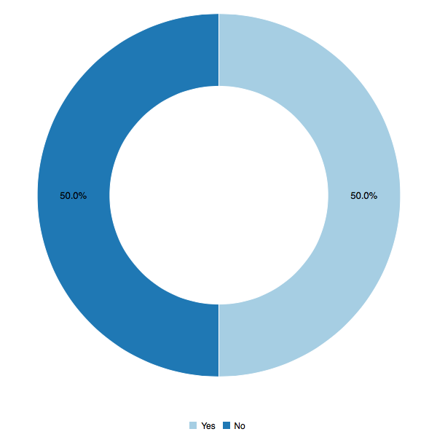
What is the most important reason to wash hands with soap?
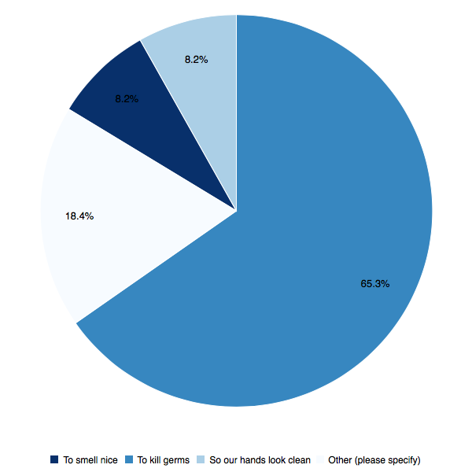

Student Perspectives on Inclusion
EXAMPLE ONLY
How much of a problem do you think there is in your community with people being harassed or discriminated against?  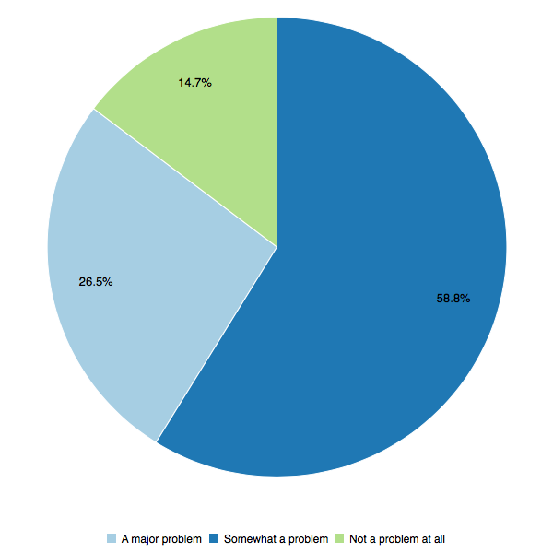 | How do you feel that your school meets the needs of people with disabilities?  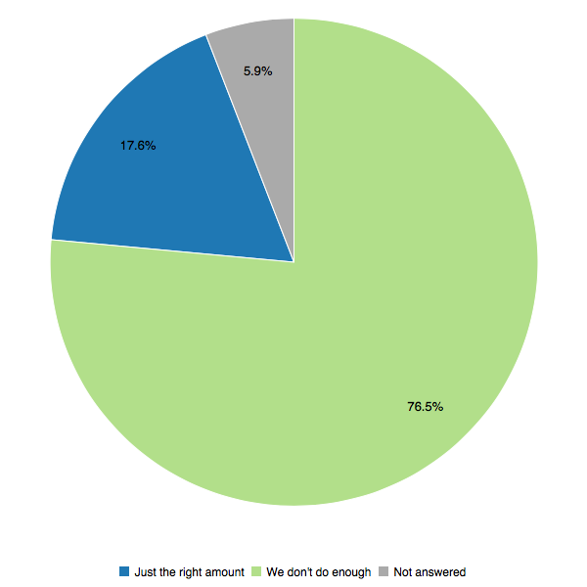
How do you feel that your school meets the needs of women and girls?  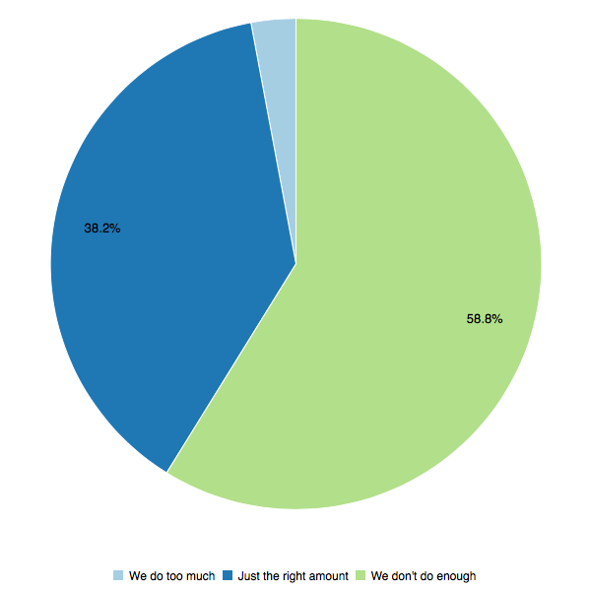 | Do you personally have any contact with people with physical or learning disabilities?  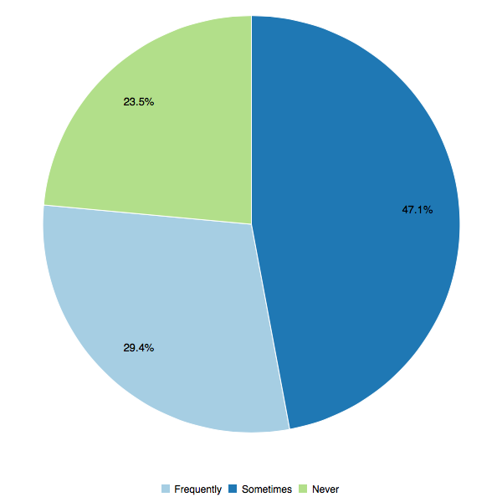

In your school what do you think are the three most common reasons why people experience discrimintation and/or harrassment?
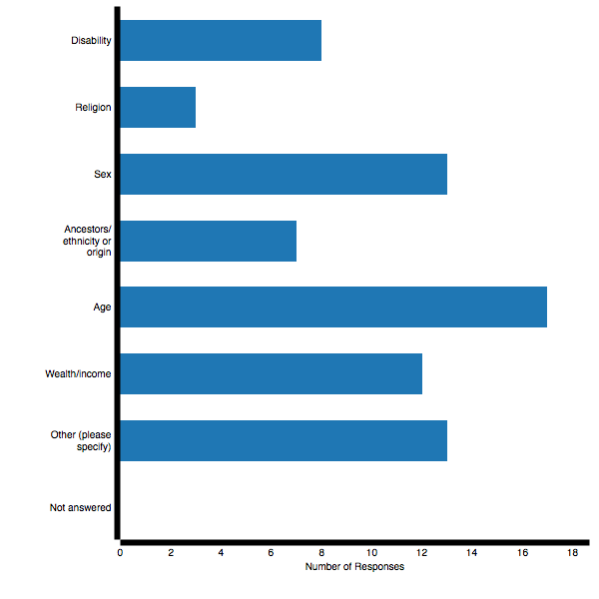
Have you personally experienced discrimination or been treated unfairly by others because of your….?
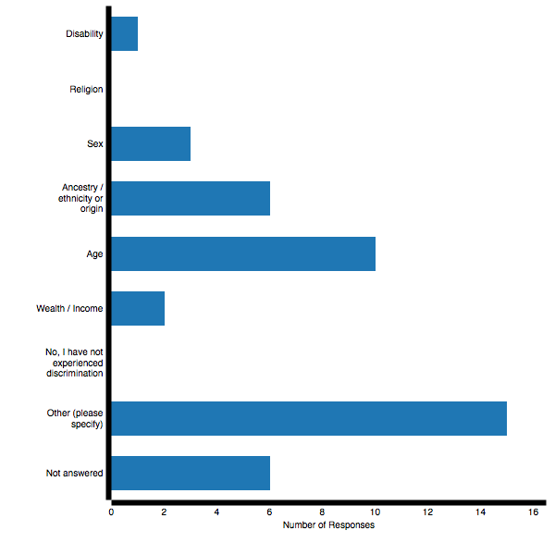
What do you know about childrens rights?  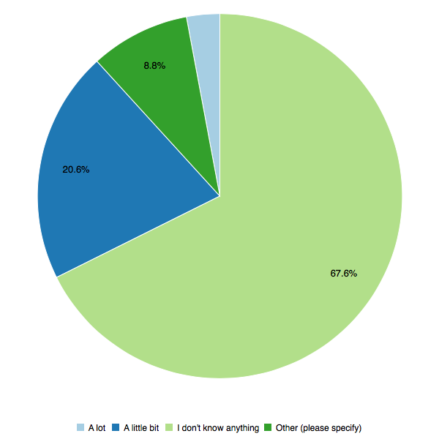 | Is everyone in your school treated equally?  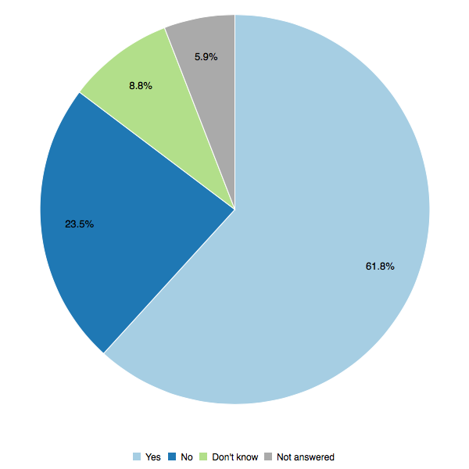
Do you think girls should get the same opportunities as boys?  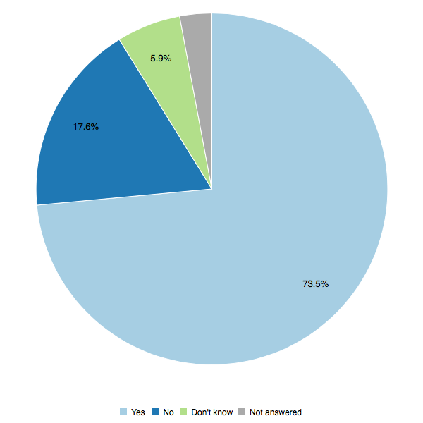 | Do you think young people should be consulted in important decisions?  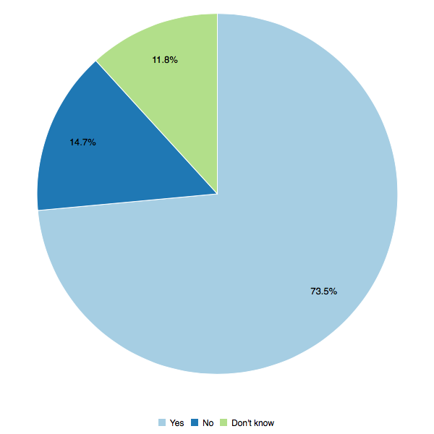

A PNGAus partnership initiative implemented by Plan International Australia with Live & Learn Environmental Education on behalf of the Australian Government

